TERMS OF REFERENCE FOR: SO2 ENGAGEMENT PLANNING

Post Title | ROYAL NAVY DOMESTIC ENGAGEMENT TEAM  SO2 ENGAGEMENT PLANNING
HRMS, JPA or Magellan Number
Rank/Grade | OF3
Branch | Military
Location | NCHQ, LEACH BUILDING, WHALE ISLAND
Level of Security Clearance Required | SC

BACKGROUND

- The Royal Navy Domestic Engagement Team (DET) is a sub-team of wider RN Domestic Engagement (DE), under the 2* leadership of Director of Strategy and Policy (DSP). DE is accountable for the design, planning and delivery of all DE activity across the UK. The purpose of DE is to build and maintain relationships with influential individuals and organisations against the DSP Campaign Objectives and RN priorities areas.

- DET is responsible for the design and delivery of national DE events, and also to support partners within the wider RN DE structure in the delivery of regional DE events - Naval Regional Headquarters, parliamentary engagement, the maritime enterprise inititiative, the use of the Royal Marines Band Service as a key strategic engagement assest, the activity of the Mobile Egnagement Team (MET) and the Maritime Reserve.

- This role is a challenging, pivotal position, managing up to support the efforts of senior partners, whilst driving the integrity of the central DE ‘recognised picture’ and developing the evaluation framework. The Royal Navy Strategy (OS MODNet) is strongly recommended reading HERE.

- This is a rare opportunity to contribute to strategic development, to design and lead major events with generous ‘mission command’, and to play a part in some of the most iconic national events in national hstory. In this year alone the role has played a pivitol part in the Queen’s Platinum Jubilee, Falklands 40, 1SL conference activity, Beating Retreat and Armed Forces Day. Continuity and networking play an important part in the role, and subject to contractual limitations, RN DE would seek to retain the successful candidate for several years.
ROLES DESCRIPTION

- SO2 Engagement forms part of a team providing flexible Engagement capability to a number of customers within the RNDE enterprise. This includes the national management and delivery of engagement events, including strategic engagement opportunities as well as maritime ceremonial components, as scheduled by the robust Planning and Governance function.

- Engagement Delivery. Engagement in this context is defined as an act of building and maintaining relationships with influencial individuals and organisations, to better understand audiences and create true advocates through genuine two-way engagement.

- Key tasks for SO2 Engagement Planning include:
- The planning and and delivery of all national level DE Event commitments, either through direct delivery of an RN obligation or the support of partner organisations.
- To act as the DE lead for integration of the RN with any event Operationally delivered, and to develop relationships with all tri-service stakeholders.
- To provide strategic input to event guest targeting, to support campaign objectives.
- To provide support to Domestic Engagement Manager and SO2 Mobile Engagement Team toward the delivery of Regional and Mobile engagement activity.
- To lead the DE Scrum (Scum Master) and integrate DSP Campaign Planning with Engagement Targetting.
- To coordinate DE partners in the development of DE insights, KPI and outcome evaluation.
- To integrate planning and event delivery with RN Comms and Influence.
- The coordination of non-event related business cases.
- Forecast and reporting of DET and MET T&S Budget.
- The post holder reports to C1 Engagement TL.

- The post holder works rank agnostic to support DE partners and to improve collaborative working benefits, including NRCs, RMBS, Maritime Enterprise, Parliamentary Engagement and Marine Reserve Engagement.

AUTHORITY AND COMMITTEES

- The post holder is authorised to:

- Liaise with internal and external agencies as required to deliver delegated outputs.
- Liaise with DS Sec (Defence Major Events Team (formerly CECT) as required in the delivery of nationally focused events.

- Attends:

- Full range of Director Strat Pol/DD Pol and Eng SCRUM meetings.

COMPETENCIES AND SKILLS

- The post holder must have strong leadership and strategic thinking skills, being able to be creative in capitalising on engagement opportunities to the benefit of the Royal Navy.

- Must have excellent people handling skills in both small and large scale events, remaining able to stage manage senior officers and civil servants as required, with the tenacity to handle unexpected circumstances and potentially turn them to the advantage of the Royal Navy.

- Skills level with Defence ICT (DII/MODNET, MS Office, MOSS): Intermediate
EXPERIENCE

- Essential experience
  - Extensive experience in the design and delivery of Defence Engagement.
  - Experience of event delivery against formatted orders.
  - Evidence of ability to effectively support and collaborate at all rank/grade levels.
  - Evidence of successful programme (multiple project) delivery across diverse stakeholders against challenging timeframes and budgets.

- Highly desirable experience
  - Defence Communicators Course/Comms role experience.
  - PSC(j).
  - Project Management qualification (PRINCE2, ACMP or equivalent) or equivalent CV experience.
  - Experience in insights, KPI and outcome evaluations.

- Experience of MOD budget management and commercials.
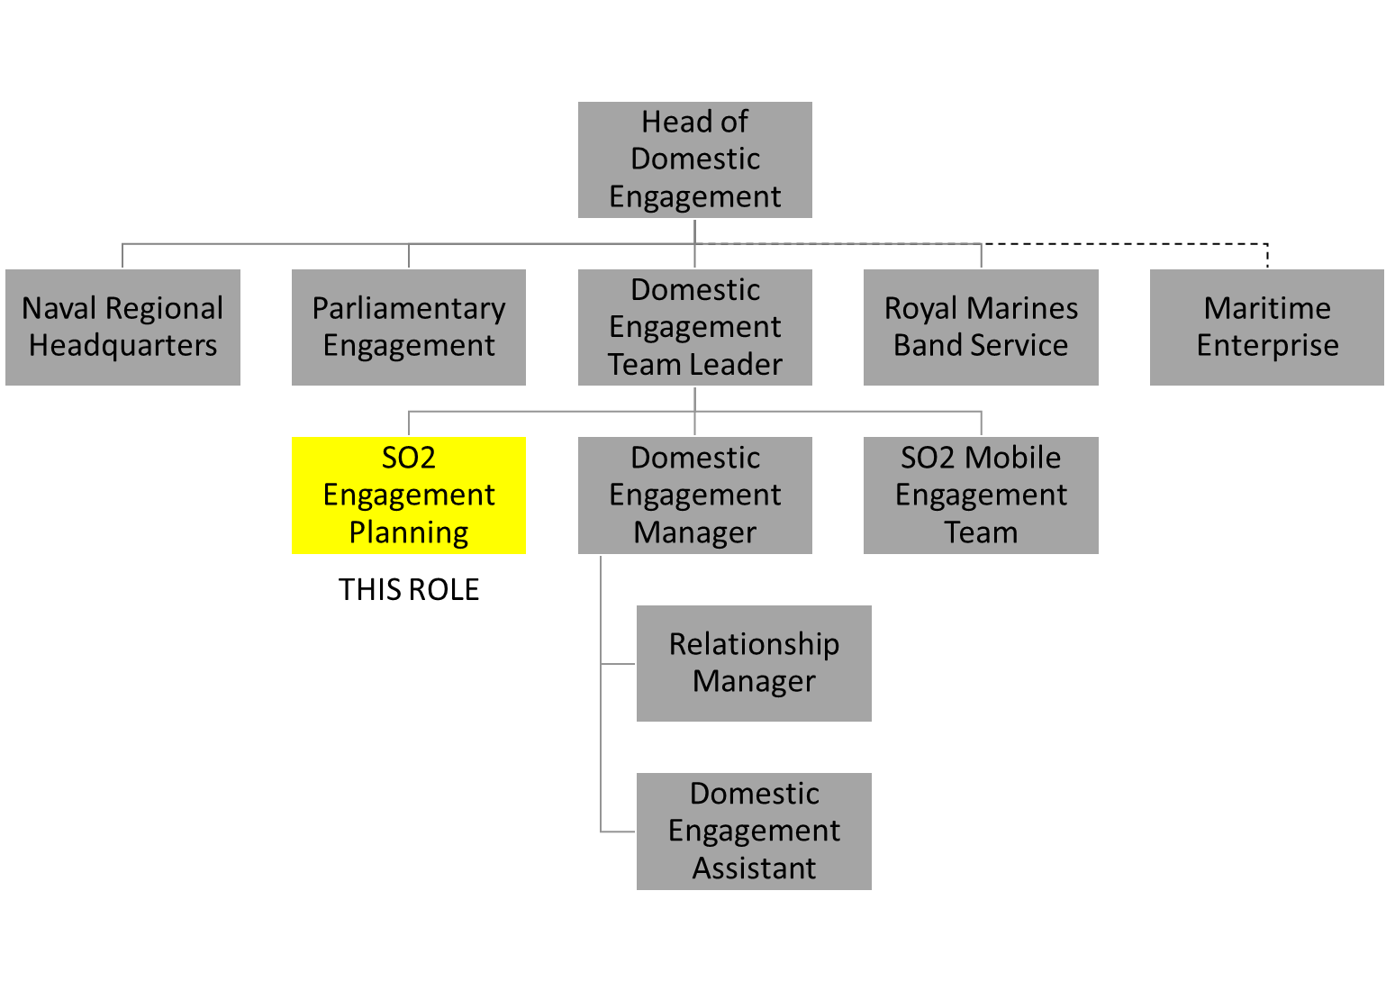
- DOMESTIC ENGAGEMENT STRUCTURE

- Role sponsor is Jesscia McKeever (Jessica.mckeever100@mod.gov.uk).

