Date issued: 5 Dec 22
Review period: 12 months
Review date: 4 Dec 23

TERMS OF REFERENCE FOR THE DEPARTMENT OF THE CORPS COLONEL MOUNTAIN LEADER FIRST CLASS

PURPOSES

1. Primary Purpose. To conduct associated activities in support of Royal Marines Recruitment & Attraction (R&A) for the Department of the Corps Col (DoCC) and provide SME knowledge, including the planning, execution and delivery of outreach events involving rope work and/ or industrial rope access. Responsible for managing and supervising all rope work activities whilst working at height in accordance with Rope Access Supervisors Manual and/ or the Military Vertical Assault Manual. Deliver Working at Height (WaH) and Military vertical assault training for CAT Ranks.

2. Secondary Purposes.

- Maintain all WaH equipment in accordance with PPE work Regulations 1992 for both military and civilian personnel.

- Primary AinU custodian.

- Produce Risk Assessment Incl Dynamic Risk Assessment Method Statements to support events.

- Produce PXR for all ML related events.

- Support the Chain of Command.

f. Deputize for CAT Tp Sgt and/ or OC CAT in their absence.

g. To undertake duty SNCO duties, as directed by DoCC CSM.

ACCOUNTABILITY

3. The DoCC ML1 post is:

- Accountable to the DoCC HQ.

- Responsible for safe conduct of all WaH activities.

- Accountable for enforcing all control measures highlighted in the Risk
Assessment when WaH.

- Accountable for maintaining all PPE equipment.

- Subject to the functional authority of CO SW, CTCRM for general military
matters.

AUTHORITY

4. The ML1 post has authority:

- Overall military and civilian personnel when carrying out activities at height as
the ML1 holds the risk for Hd R&A.

- To liaise with internal and external agencies and authorities in an outreach
capacity.

ORGANISATION

- Organisational Diagram.

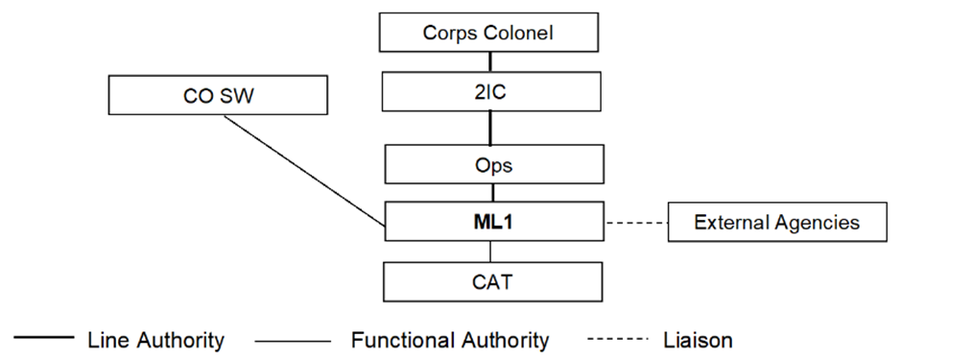

PRINCIPAL TASKS

6. Include the following:

- Teach and assess the Commando Attract Team’s (CAT) roping capability and
ensure the required standards are maintained.

- Maintain current and competent in all Military Vertical Assault aspects and
Rope Access procedures.

c. Evaluate and ensure the safe conduct of all rope-work activities at height through reconnaissance whilst complying with current legislation.

d. Deliver all climbing, abseil and zip line activities for the CAT and public during outreach engagement activities.

e. Liaise with CHF to ensure all team members are in date for helicopter abseil/ fast rope work.

ADDITIONAL TASKS

7. Conduct and support PDEV training opportunities for DoCC personnel, to better prepare individuals for CF activities. Support RMART tasks and requirements, providing they do not conflict or affect the DoCC principal tasks.

8. ESSENTIAL QUALIFICATIONS

a. Security Clearance.

b. SWAH Supervisors Qualification Incorporating the relevant regulation in respect of BS 7985-2013/ISO 22846-2012.

c. Certificate of Competence in the inspection of Personal Protective Equipment (PPE) for work at height and adventure training activities (Currently run at Lyon Work & Rescue).

9. CTCRM - SPECIFIC TRAINING

a. New Joiners Induction Brief (CTCRM Unit Induction Training).

b. Basic Care of Trainees (DLE).

c. Disclosure and Barring Service certificate (form completed in CTCRM UPO).

10. DEFENCE - MANDATED TRAINING

a. Radicalisation Prevention Training (DLE).

b. Mental Fitness Training (DLE).

c. Fraud, Bribery and Corruption Training (DLE).

d. Heat Illness Protection Module 1 Training (DLE).

e. Defence Information Management Passport Training (3 Modules on the DLE).

11. NAVAL CORE TRAINING - CORE FITNESS

a. NCT 1 - Fitness Test Practical (local PTI).

b. NCT 2 - First Aid Training (F2F or DLE).

c. Unacceptable Behaviours Training (DLE).

d. Musculoskeletal Injuries Training (DLE).

e. NCT 9a - Basic Safety Awareness Training (DLE).

f. Radicalisation Prevent Training (DLE).

g. NCT 9b - Human Factors Training (DLE).
12. NAVAL CORE TRAINING - CORE EDUCATION

a. NCT 3 - Security Awareness Training (F2F or DLE).

b. NCT 4 - Advanced D&I Training (F2F or DLE).

c. NCT 5 - Substance Misuse Training (DLE).

d. NCT 6 - SERE A Training (DLE).

e. NCT 7 - Operational Law Training (DLE).

f. Unacceptable Behaviours Training (DLE).

g. Personnel Information Check (SCIO).

9. DESIRABLE.

a. Single Pitch Award (SPA).

b. Climbing Wall Award (CWA).

L McBain
Sgt RM Maj RM
DoCC ML1 DoCC 2IC

