Issue Date: XX Nov 20

Review Date: XX Nov 20

TERMS OF REFERENCE FOR NAVY PEOPLE PLANS ROLE ANALYSIS ENG 3 – N5 RA ENG 3

Preamble

- Director Personnel and Training (Dir P&T) directs and develops the organisation for Branch Sustainability for the RN, RM, RFA and Maritime Reserves to meet the manning requirements of the Service in peace, crisis or war in accordance with authorised priorities. Working for Head People Plans (N5 People), the N5 RA team contributes by articulating the Service requirement for individual training of manpower and ensuring that such training is delivered efficiently and effectively.

Purposes

2. Primary Purpose. The Post Holder is to:

- Act on behalf of the RN’s Training Requirement Authority (TRA) to set, review and manage qualitative training requirements, based on employment needs,

- Conduct Role Analysis leading to the production of, or amendment to, a Role Performance Statement (Role PS) or Competence Framework (CF) IAW N5 Role Analysis Quality Management System (N5 RA QMS)

3. Secondary Purposes: The Post Holder is responsible for:

- Reviewing N5 RA Tasking Requests to ensure that they fit within the remit of Role Analysis and make recommendations to the TRA when outside of this remit.

- Advising the TRA on the extent to which proposed training solutions meet the articulated requirement.

- Quality assurance of Role PS within the N5 RA team IAW N5 RA QMS.

- Providing advice and guidance on the Defence Systems Approach to Training (DSAT).

Line Management

4. N5 ENG 3 is accountable to:

a. SM TRA TM SO3 for the production and review of Training Requirements in accordance with agreed workplan and timings.

b. SM TRA TM SO3 for the distribution of taskings related to production or maintenance of the Role PS/CF and subsequent mapping of the training solution.

5. Post Holder is functionally accountable to:

a. N5 RA SO2 on behalf of N5 People. N5 RA SO2 will hold N5 RA ENG 3 directly accountable for the timely delivery, quality and accurate articulation of all taskings mentioned in para 4, IAW N5 RA QMS and JSP 822.

b. N5 RA SO2 for raising task priority and capacity issues.

c. N5 RA SO2 for providing general DSAT advice and guidance to training stakeholders.

6. First Reporting Officer (1RO) is SM TRA MESM SO3 and Second Reporting Officer (2RO) is BM TRA SM SO2.

Authority

7. In the conduct of their primary and secondary purposes, N5 RA Eng 3 is authorised to liaise directly with MoD departments, NCHQ, Defence Training Establishments and associated Service and civilian organisations in the course of routine business, as defined by these Terms of Reference.

Tasks

8. The Post Holder is to:

- Scope new RA tasking received from the TRA, providing recommendations as to whether Role Analysis or partial Role Analysis is recommended or not recommended.

- Develop, review and amend Role PS/CF.

- Actively engage with the N5 RA CPD Programme.

- Maintain the N5 RA Masterlist and Workplan to accurately reflect both individual and N5 RA Team wide tasking.

- Provide assurance to the TRA that the training solution articulated in the FTS meets the requirement stipulated in the Role PS.

- Liaise with stakeholders in the conduct of RA.

- Ensure endorsed training requirements are passed over to the relevant training design organisation for Stage 1 training and design development.

- Conduct quality checks of Role PS developed by other analysts and contractors.

- Promote the role of RA within DSAT amongst training stakeholders.

- Act as a RA mentor to new joiners of the N5 RA team.

- Undertake miscellaneous tasks, as directed by N5 RA SO2 and ESM TM SO3 on behalf of N5 People.

- To act as a TAFMIS Administrator.

Competences

9. In general, the post holder is to be OR8/OR7, in order to discharge the primary and secondary purposes. In addition, the post holder requires the following specific competences:

Competence | Course Ref | Skill Level
NCHQ structures and responsibilities  DSAT Course – Training Needs Analysis  DSAT Course – Training Design  TAFMIS(T) TIS-TAD User | Induction  DCTS 9009  DCTS 9005  TAD(TDT) | Adv  Int  Adv

Annex A: Navy People Plans Role Analysis (N5 RA Team) Hierachy Flowchart

Annex A to N5 . RA ENG3 ToRs

Navy People Plans Role Analysis (N5 RA Team) Hierachy Flowchart

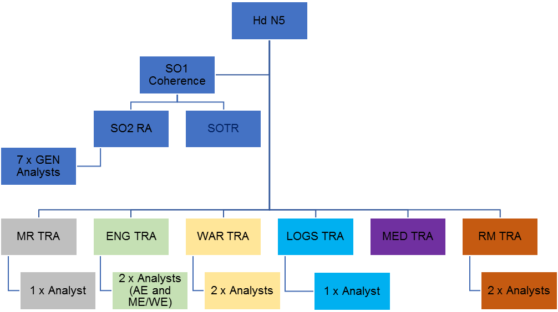

SO2 RA has functional authority over Analysts for QA and additional taskings on behalf of Hd N5

To Note:

- TRA line manages and tasks Analyst directly
- SO2 RA to line manage GEN analysts
- SO2 RA to have functional authority over all Analysts

