TERMS OF REFERENCE FOR:

SO3 REGIONAL ENGAGEMENT (NRC EE)

Post Title | Naval Regional Commander (Eastern England)  SO3 REGIONAL ENGAGEMENT
HRMS, JPA or Magellan Number | 2053456
Rank/Grade | OF2/ OR9
Branch | RN FTRS FC
Location | HMS PRESIDENT (central London)
Level of Security Clearance Required | SC

BACKGROUND
- NRC EE is charged with protecting and enhancing the reputation of the Royal Navy. It does this by delivering against the Royal Navy Director of Strategy and Policy Engagement Plan, applying focussed resources to protect and improve levels of favourability and understanding amongst the Royal Navy’s six key target audiences.

- In order to deliver the overall approach to RN engagement efforts, they are organised along Strategic Campaign Plans which are regularly reviewed.

- An integrated process which starts with planning and concludes with research, insight and evaluation (RIE) lies at the heart of all engagement activity. Everyone is expected to ensure that all engagement activities are informed by insight and evaluated in line with Roayl Navy policy.

- Each position comprises a principal role, plus additional roles. Using a combination of roles, post holders are expected to build dynamic teams from across the enterprise based on project needs, enabling better cross-fertilisation of ideas and improving efficiency. A number of functions provide support in order to facilitate this process. There are 4 NRCs each with 2 SO3s who conduct the regional engagement within their allocated region. The East of England region streaches from the Humber to the Isle of Wight and Derbyshire to Kent and includes London where this post is based.

ROLES DESCRIPTION

- SO3 Regional Engagement forms part of a team providing engagement capability to regional stakeholders on behalf of the Royal Navy. They are permanently located in one of the four Naval Regional Commands, providing regional management and delivery of engagement events, including RNIPE as well as maritime ceremonial components, as scheduled by the Domestic Engagement Team central planning function.

- Regional Engagement Delivery. Engagement in this context is defined as an act of Communication through the brokering of effective person-to-person contact at an appropriate level. Engagement allows the RN to exert appropriate influence over those groups that have the greatest effect on its future strategic success. Key tasks involve:

- Project management, operational planning and delivery of regional engagement events as scheduled and directed by the central DET planning function.
- Coordinate NRC regional engagement programme.
- Assist in the development of business cases, design of SMS submissions and the management of resulting financial arrangements for regional engagement events, providing information as required to the central engagement team.
- Track and report event expenditure to the Chief of Staff.
- Provide feedback on the efficacy of regional engagements particularly on responses to the Universal Questions and other quantitative and qualitative approaches as deemed appropriate
- Campaign and Planning Support. This role is responsible for supporting the development, planning and execution of campaigns and engagement activities. Key tasks involve:

- Work with COS to establish and agree campaign requirements.
- Take part in the campaign team from within NRCEE including appropriate roles, experience and expertise to deliver the campaign.
- Assist in the running of a campaign according to the campaign plan and use evaluation data to optimise campaign activities.
- The post holder works closely with and reports to NRCEE COS.

AUTHORITY AND COMMITTEES

- The post holder is authorised to:

- Liaise with internal and external agencies as required to deliver delegated outputs.
- As directed, liaise with DS Sec (Ceremonial Events and Commemorations Team) and the DET) as required in the delivery of nationally focused events.

- Is the Secretary of the Regional Coordination Group (RCG)

- Attends:

- Full range of NRC EE Battle Rhythm meetings.

ORGANISATION

- Organisation Diagram for the 4 NRCs is below:

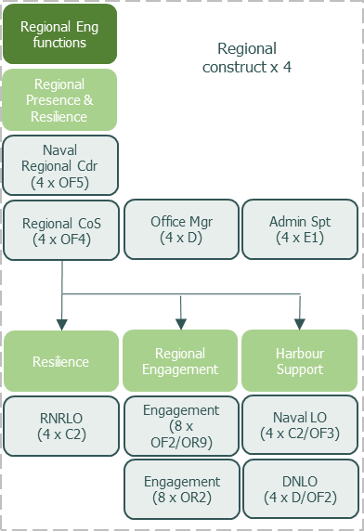

COMPETENCIES AND SKILLS

- The post holder must have strong leadership and strategic thinking skills, being able to be creative in capitalising on regional engagement opportunities to the benefit of the Royal Navy.

- Must have excellent people handling skills in both small and large scale events, remaining able to stage manage senior officers and civil servants as required, with the tenacity to handle unexpected circumstances and potentially turn them to the advantage of the Royal Navy.

- Ideally, the post holder should have acquired some communication skills and knowledge from previous postings. Building on this, the post holder must agree with the Line Manager on the training necessary to attain the required level of GCS communication competency as below:
GCS Competency Framework | Level (0-6)
Insight: Gain an accurate and deep understanding of the issue(s). Use insight to identify target audiences and partners and to inform engagement objectives, messages and solutions. | 2
Ideas: Develop the engagement strategy and plan. Select channels and develop key messages and content for target audiences. Identify evaluation criteria. | 2
Implementation: Develop and implement effective engagement strategies and plans. Work with stakeholders and partners to deliver communication. | 2
Impact: Assess the impact and effectiveness of engagment. Review achievement of objectives. Identify lessons learnt and share feedback. | 2

- Skills level with Defence ICT (DII/MODNET, MS Office): Intermediate
EXPERIENCE

- Essential experience

- Defence Engagement
- UK/EU Civilian Driving Licence to category C+E and D
- ICSC(M)

- Highly desirable experience

- DCC
- Project Management (PRINCE2, ACMP or equivalent)

