CHAPTER 4C

Diving and Threat Exploitation Group (DTXG)

Chief Petty Officer Diver CPO(D) Coord

(DTXG CPO(D) Coord)

Preamble

            - DTXG Chief Petty Officer (Diving) Coord (DTXG CPO(D) Coord) will be responsible for coordination of all pan-DTXG orphan diving equipment training, SMERAS assets and nominated personnel directly supporting Op LONGSTONE, and MTE. This is a pan-Group activity requiring close liaison with all Diving Squadrons in DTXG.

Purposes

- Primary Purpose: To coordinate, manage and plan FDEV and FMAINT activity of a pan-DTXG nature in order to maintain currency and competency (C&C) of personnel in specific, orphan diving equipment, to sustain Op LONGSTONE directed outputs (SMERAS and NSRS), and assist the HQ CPO(D) with operational delivery of MTE. This activity will require liaison, as necessary, with external agencies and respective Diving Squadrons to ensure currency and resilience of FE@R is maintained.

- Secondary Purpose:

  - To undertake wet and dry diving to support DTXG Command Plan (CP) directed outputs.

  - To maintain currency and competency in authorised diving equipment required to support DTXG CP outputs.

  - To co-ordinate, through respective Diving Squadrons, succession and training plans necessary to sustain Op LONGSTONE operational outputs on behalf of the CO DTXG.

  - To act as the primary focus for all Recompression Chamber (RCC) (Type B, TMCC and NSRS TUP) matters in DTXG, ensuring SOTT/SOTR requirements are captured and input accordingly.

  - To directly support Op LONGSTONE as a NSRS Supervisor, contributing to the DTXG FE held @R1 (48 hrs NTM).

  - To maintain visibility of all DTXG RCC maintenance and operational capability.

  - To be the primary liaison in DTXG for the NSRS Diving Officer (DivO), coordinating NSRS training activity as necessary.

  - To be the DTEG booker and administrator for the NDAC TMCC.

  - As directed by WO1(D) DTXG, act as a member of RN Mar-IEDD Directing Staff (DS) Panel in support of all DTXG MEOD and Mar-IEDD Validation exercises.

  - To be a JSIEDD No1 Operator and maintain licencing currency iaw JSSOPS.

  - To maintain fitness to dive and remain in-date medically via Annual Diving Medical (ADM).

Superiors

- The DTXG CPO(D) Coord is:

  - Accountable to the Operational Support Squadron (OSS) Group Ops Officer (GOPSO).

  - Under the functional authority of GOPSO for discipline, divisional matters and day to day administration.

Authority

- The DTXG CPO(D) Coord is authorised to:

  - Release signals and sign correspondence of a non-policy nature as required.

  - Liaise with, at the appropriate level, staff of SDA on higher level squadron Op LONGSTONE matters affecting DTXG units and external organisations.

  - Liaise with, at the appropriate level, SDA/MWS/DDS staff regarding training and course programming matters in connection with RCC, NSRS TUP, and orphan diving equipment courses.

  - Liaise with those Service authorities, which provide services to the DTXG and constituent CDUs.

Organisation

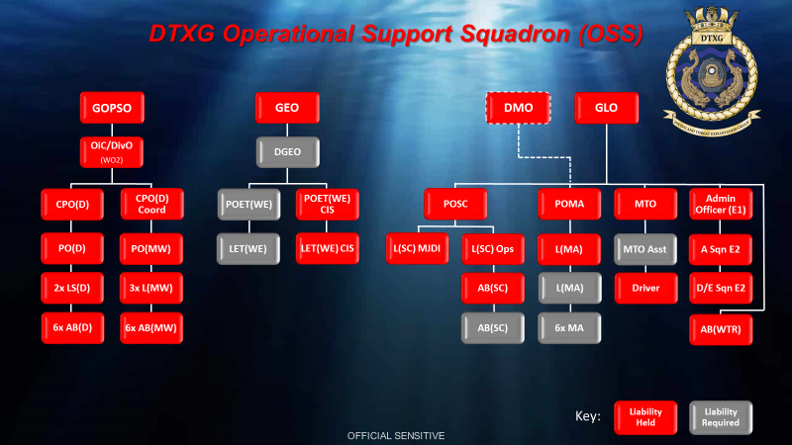

Competencies

- Essential competencies:

- Professional|RPS for PO(D) |Navy
- Explosives|EOD OP|Joint|
- Explosives|Defence EOD Op CMD|Joint|
- Diving|RN Advanced UW EOD|Navy|
- Diving|NSRS Operator|Navy
- Diving|NSRS Supervisor|Navy|
- Management|Divisional Officer (RNLA 106)|Navy|
- NBCD|Intermediate Sea Safety Course|Joint|
- Diving|Military Diver First Aid (DDS 124)|Navy|
- CMS|CMS4 Surface Ship Sea Safety and CBRNDC|Navy| (Perodicity – BR 2170(1))

- Desirable competencies:

- AA|EOD (IEDD) No1 JS|Army| (Qualified).
- Instructional|Supervision and Coaching of Instructors|Joint|

Signed: Date:

Post Holder Line Manager

