TERMS OF REFERENCE: TMG IDT(RN) COS
PART A – POST DETAILS
Post Title | SO2 IDT(RN)
Grade | OF3
Location | Phoenix Building, Whale Island
JPA Number | 2116638
HRMS Job Family/Job Code
Line Manager Name/Grade | TMG IDT(RN) SO1
Day-to-day Supervisor (if different)
Countersigning Officer Name/Grade | Comdt TMG
Working Pattern  (FT/PT/Alternative)/hours | FT
Security Clearance Required | SC

PART B - ORGANISATION & BACKGROUND
Details of Organisation/Business Directorate
The post holder works as part of International Defence Training (Royal Navy) (IDT(RN)) and is primarily responsible for day to day management of the team on behalf of the SO1 IDT(RN). The post holder works across all aspects of IDT(RN) business, developing Defence Engagement and IG opportunities and in collaboration with Team Fisher to modernise and develop modern and progressive RN training for international partners.
Job Purpose
The post holder will be required to deputise for the SO1 IDT and subject to delegated authority will be required to:
- Work in collaboration with Team Fisher, managing IDT business activities, liaising with internal and external stakeholders and supervising the progress of workstreams and activity programmes out to one year.
- Assist with the management of IDT Government to Government (GtoG) activity in accordance with JSP510 and local guidelines.
- Advise and liaise with MOD and Navy Commercial finance officers on contract/licence/pricing requirements for Wider Markets (WM).
- Ensure that proposed GtoG and WM activity complies with policy and guidance - particularly legal, insurance and pricing requirements.
- As part of the Team Fisher modernisation agenda, regularly review, refresh, and modernise IDT course offerings to meet evolving international partner needs.

1

- Represent SO1 IDT in both the UK and overseas, promoting IDT objectives and in doing so, supporting broader Defence Engagement priorities and the Global Britton and prosperity agenda.
- Attend IDT and TMG Command Group level meetings – empowered to provide updates on all matters of core IDT business including morale, welfare and whole-ship training.
- Provide SME input to staff papers, briefings and other correspondence on the subject of international training.
- Lead on the IDT Management of Information (MI) and executive issues, including Security (working with TMG USO on pan-TMG issues).
- Act as a line manager and Divisional Officer, overseeing the welfare of the workforce and coordinating whole-ship training, ensuring all mandatory Civil Service and military training is achieved. Oversee the induction of all new team members following TMG processes.
- Manage the Divisional and reporting system, providing general advice on personnel issues, channelling specific casework to Command and the relevant specialist organisations. Act as the focal point for the dissemination of policy matters.
- Ensure that the highest values and standards of the Service are maintained with emphasis on all aspects of diversity and inclusivity.
The post holder shall note that these approved TORs seek to describe the extent of the role and its responsibilities, as far as practicable. Ultimately, however, it is up to the individual to achieve the job purpose using their leadership, professional ability and management skills. Thus, these TORs should not be seen as prescriptive and post holders are expected to exercise initiative and be innovative, which may require operating outside their TORs. In these circumstances post holders are not to be constrained by their TORs in achieving success but must ensure that their line manager and others are kept informed as appropriate.
Organisation Chart
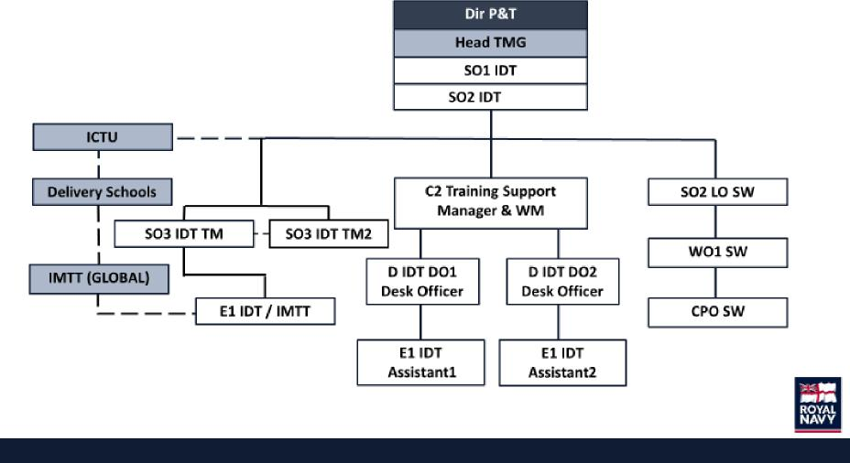
2

PART C - RESPONSIBILITIES
Responsible for: | Percentage
Work in collaboration with Team Fisher, managing all IDT business activities, liaising with internal and external stakeholders and supervising the progress of workstreams and activity programmes out to one year. | 30%
Assist with the management of IDT Government to Government (GtoG) activity in accordance with JSP510 and local guidelines. | 10%
Advise and liaise with MOD and Navy Commercial finance officers on contract/licence/pricing requirements for Wider Markets (WM). | 10%
Ensure that proposed GtoG and WM activity complies with policy and guidance - particularly legal, insurance and pricing requirements. | 10%
As part of the Team Fisher modernisation agenda, regularly review, refresh, and modernise IDT course offerings to meet evolving international partner needs. | 10%
Represent SO1 IDT in both the UK and overseas, promoting IDT objectives and in doing so, supporting broader Defence Engagement priorities and the Global Britton and prosperity agenda | 5%
Attend IDT and TMG Command Group level meetings – empowered to provide updates on all matters of core IDT business including morale, welfare and whole-ship training. | 5%
Provide SME input to staff papers, briefings and other correspondence on the subject of international training. | 5%
Lead on the IDT Management of Information (MI) and executive issues, including Security (working with TMG USO on pan-TMG issues). | 5%
Act as a line manager and Divisional Officer, overseeing the welfare of the workforce and coordinating reporting and whole-ship training, ensuring all mandatory Civil Service and military training is achieved. Oversee the induction of all new team members following TMG processes. Act as the focal point for the dissemination of policy matters. | 5%
Ensure that the highest values and standards of the Service are maintained with emphasis on all aspects of diversity and inclusivity. | 5%

PART D - AUTHORITY
The SO2 IDT(RN) has the following authority:
In support of core IDT activity, liaise with internal and external authorities up to 1*.

3

PART E - SUCCESS PROFILES
The following competencies, experience and behaviours are necessary for the role of IDT(RN) COS:

Competencies:
- In date for all NCT mandatory training.
- Protecting Information Levels 1, 2 & 3.
- ICSC(M) (Desirable)
Knowledge and experience:
- Knowledge of JSP 510 IDT, JSP 622 TM & BR 3 (Naval Personnel Management) (essential).
- Broad leadership and management experience, at sea, Ops, HQ & in training (essential).
- Experience of training delivery in a RN or professional environment (essential).
- Experience of leading or participating in the senior management of training and education delivery organisations (desirable).
- Experience of developing and maintaining constructive working relationships with partner organisations / commercial partners or working within a commercial environment (desirable).
Behaviours:
- Leadership.
- Communicating and Influencing.
- Working Together.
- Seeing the Big Picture.
- Making Effective Decisions.
- Achieving Commercial Outcomes.
- Delivering at Pace.
PART F - LEARNING & DEVELOPMENT
The post holder will be required to undertake all MOD Mandatory Training related to the post and site.
The post holder will be required to maintain the currency of their knowledge and skills relating to training/ education policies, standards, theories and methodologies through ongoing CPD.
4
Post holder:
Name
Signature
PART F - SIGNATURES

Signature
Date agreed:
Date for review:
5
Line Manager: Name

