TMG TRAINING SUPPORT - TEPMT PM TERMS OF REFERENCE
Command |  |  | Director People and Training (Dir PT)
Unit |  |  | Training Management Group (TMG)
Department |  |  | Training Support Pillar
Section |  |  | Training Equipment Project Management Team (TEPMT)
Job Title |  |  | TEPMT Project Manager 3 (PM3E)
Grade |  |  | Lt RN
Line Number |  |  | Tbc (currently 2069464 due to change under WAS application)
Line Manager |  |  | TMG-TEPMT-SPM
Last Update |  |  | 14 Jun 21
Review Period |  |  | Annual
Next Review |  |  | 14 Jun 22
PRIMARY PURPOSE
To support Director People and Training (Dir PT) Capability Management (CM), operating over the scope of the Selborne contract.
SECONDARY PURPOSE
PM will provide a CDEL/RDEL training equipment (TE) resource consumption accounting forecast and useage.

When nominated, a PM will act as the overall CDEL/RDEL Financial Resource Manager for the team.
COMPETENCIES REQUIRED
Essential (to achieved within 6 months of joining)  - Association of Project Managers Project Management Qualification (APM PMQ) or PRINCE 2 Foundation  - Risk Management Introduction (Civil Service Learning)  - Commercial Awareness (Civil Service Learning)  - TLCM Introduction Training  - CP&F Requestor Training, sections 00, 01, 03A-F, 04A-D, 05 & 06  -CP&F Requirement Owner, sections 03G & H |  |  |  |  | Desirable  - Financial and Military Capability Management (Practitioner) - FinMilCap (P)  - Introduction to Defence Acquisition – IDA  - Budget Holder – EO45 (When nominated as Financial Resource Manager)  - Financial Skills Certificate Foundation  - Acquisition Employment Training (Def Ac)  CP&F
ACCOUNTABILITY

As a Government Furnished Asset (GFA) to the Selborne outsourced training contract (Selborne) contract, the PM is employed under the line authority of TEPMT-SPM for delivery of their principal tasks and to TEPMT-TPKC for Service related matters.

PM is under the functional authority of the Executive Officer HMS COLLINGWOOD for Establishment duties.
AUTHORITY
PM is authorised to:
1 |  | Liaise with external authorities, including; NCHQ, Dir PT, Defence Commercial, Dir PT Training establishments, DE&S PTs, US DoD, Non Military Agencies, Civilian Companies and Army/RAF organisations as appropriate on any matter pertaining to their primary and secondary purposes.
2 |  | Liaise with appropriate specialist officers within TMG and DE&S to ensure awareness of the future equipment programme, whilst providing advice and guidance on procedures to maintain system baselines cognisant of the NCHQ requirement.
3 |  | PM has delegated authority from Cdr Training Support to call on any appropriate SME support within the TMG for comment and advice on detailed training aspects.
PRINCIPAL TASKS
1 |  | Utilising APM/PRINCE 2 methodologies to ensure Project activity is delivered iaw the Acquisition System Guidance (ASG) approach to Capability Management (CM) and Project Management to ensure TE is delivered efficiently and effectively and meets the Project Sponsor's required capabilities, through life, across all Defence Lines of Development.
2 |  | Provide CM Project Management of TE Projects, as allocated by SPM, to deliver TE funded by NCHQ and delivered against an establishment, Dir PT or Navy Command requirement whilst minimising the impact on training delivery.
3 |  | Provide Project Management of TE removal and disposal in order to dispose of redundant TE, as allocated by SPM, ensuring TE is disposed with no impact to training.
4 |  | Provide Project Management of the repair and support of non-GFE, non-DE&S supported, bespoke TE, as allocated by SPM, in order to provide repair and support to legacy TE.
5 |  | Provide advice to DE&S Training-LOD Projects in order to facilitate defence compliant installation or disposal of TE ensuring host establishment installation and disposal standards are met.
6 |  | Provide a Project Management service to facilitate the installation and disposal of DE&S Training-LOD funded TE Projects, as allocated by SPM, to enable the Fit-to-Receive (FTR) element and oversight of DE&S TE delivery.
7 |  | Provide direction on commercial and contractor interaction to establishment staff reference TE procurement to ensure that potential TE contractors are engaged appropriately ‘Subject to Contract’.
8 |  | Scrutinise and staff all relevant papers related to the Training Projects for which he/she has responsibility. This includes, but is not limited to; SoR, URD, SRD, RCR, Investment/Options Appraisal, Business Cases and Equipment Specification documents.
9 |  | To bring to SPM and TPKC's attention any factors which could adversely affect current or future training.
10 |  | When nominated, co-ordinate TMG Training Equipment CDEL/RDEL funding bids for all training requirements identified by the TPKC.
11 |  | When nominated, produce a monthly profiled Forecast of Outrun (FOO) for NCHQ, ensuring that a detailed account of expected over/under spend is identified as early as possible in the FY.
12 |  | When nominated, provide advice and guidance relating to funding for un-planned / programmed training requirements identified by the TPKC.
13 |  | When required attend Capability/Training Integration Working Groups.
14 |  | When required in support of TEPMT business, undertake CP&F contract requisition activities. Placing demands against existing contract or catalogue item or, if necessary, creating a new contract iaw CP&F procedures.
OTHER ORDERS
This document does not relieve the PM of their obligation to comply with QRRNs and other orders and instructions which apply to him/her.
S Toone  Lt Cdr RN  TEPMT TPKC |  |  |  | XXXX  Lt RN  TEPMT PMXX
DD MMM YY |  |  |  | DD MMM YY

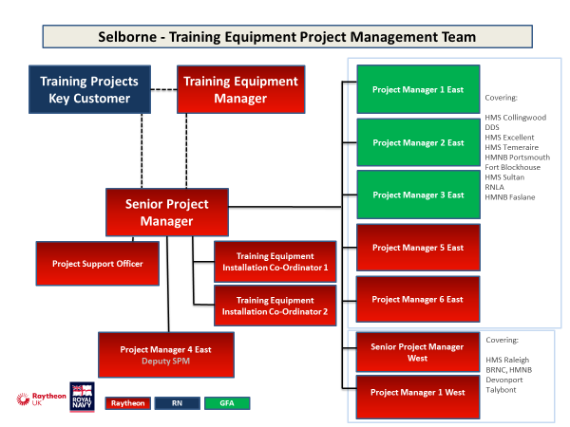
TMG TRAINING SUPPORT - TEPMT GFA DIVISIONAL STRUCTURE
TMG HQ Commandant
TMG TEPMT PM1E
Cdr Training Support
TMG TEPMT KC

TMG TEPMT PM3E
TMG TEPMT PM2E

