TERMS OF REFERENCE: TMG IDT(RN) COS

PART A – POST DETAILS

Post Title | IDT SO3
Grade | OF2
Location | West Battery, Whale Island
JPA Number | 1441259
HRMS Job Family/Job Code | N/A
Line Manager Name/Grade | Major Richard Kettle (IDT SO2)
Day-to-day Supervisor (if different) | N/A
Countersigning Officer Name/Grade | Cdr Christopher Hammond (IDT SO1)
Working Pattern (FT/PT/Alternative)/hours | FT
Security Clearance Required | SC

PART B - ORGANISATION & BACKGROUND

Details of Organisation/Business Directorate
The post holder works as part of International Defence Training - Royal Navy (IDT(RN)) and primarily has responsibility for the development and co-ordination of Navy Command’s Government to Government training activities. The post holder works across all aspects of IDT(RN) business, including planning long term activity, leading on the SOTT/SOTR process and, when required, assisting the facilitation of Wider Markets training.

Job Purpose

Primary Purpose: Assist the direction and coordination of Royal Navy and Royal Marine Government to Government training for members of Uniformed Forces of Foreign and Commonwealth (F&C) countries. Specifically to support Establishments, Project Teams and Business areas with the following:

a. Assist with the management of IDT(RN) Government to Government training activity in accordance with policy and guidelines set by MOD (JSP510);

b. Ensure that proposed Government to Government activity complies with relevant policy and guidance, particularly in relation to legality, insurance, pricing and reputation;

c. Refer any matters requiring policy or functional guidance as necessary to the appropriate authority e.g. DE Strat, ITP, NS Eng, FOST, Wider Markets Team, DIPR;

d. Provide advice and liaise with, the appropriate commercial and finance officers on contract/licence/pricing requirements.

e. Act as IDT Requirements Manager, leading on the contracted training SOTT/SOTR process, and ensure that IDT GtoG training complies with contract requirements.

f. Maintain oversight of IPP prioritisation and funding issues, ensuring GtoG are using the up to date Forward Allocations Board notification for Tier 1 training.

g. To be responsible for the IDT(RN) Catalogue as coordinator/producer for both paper and web versions (at www.royalnavy.mod.uk/idt ). Liaising with the GtoG section and training establishments for changes in course content and the Navy Publications Graphics Organisation (NPGO) to update content for both.

Secondary Purposes:
a. Provide advice on RN input to tri-Service IDT Policy;

b. Lead on the production of IDT(RN) GtoG management information;

d. Produce training and financial data and reports on IDT GtoG activity;

e. Deputise for SO2 IDT in their absence;

f. As required, produce Briefs and Presentations on IDT GtoG activity;

g. When required, provide assistance to Training Support Manager with IDT related Wider Markets activity.

h. To be the Low Value Purchasing officer for IDT(RN) marketing materials.

In addition to tasks directly associated with primary and secondary purposes, SO3 IDT tasks shall include but not be limited to:

a. Manage training records and procedures.

b. Provide information and briefing material on RN/RM courses as required in the form of PQs, input to Ministerial and high level MOD briefs.

c. Provide advice on student welfare and administration.

d. Liaise with DE Strat, ITP and Defence Sections overseas, as necessary, on funding issues.

e. Advise, as appropriate, on entry tests and pre-course requirements for prospective overseas students.

- Liaise with PSyA and Training Establishments on the security implications of offering
training to the foreign countries, including guidance on raising Risk Balance Cases.

- Present briefings to Embassy/High Commissions staff as required.

- Analyse, summarise and assess student reports and pass information to stakeholders.

- To carry out ad hoc tasks as requested by SO1 IDT and/or SO2 IDT.

Organisation Chart

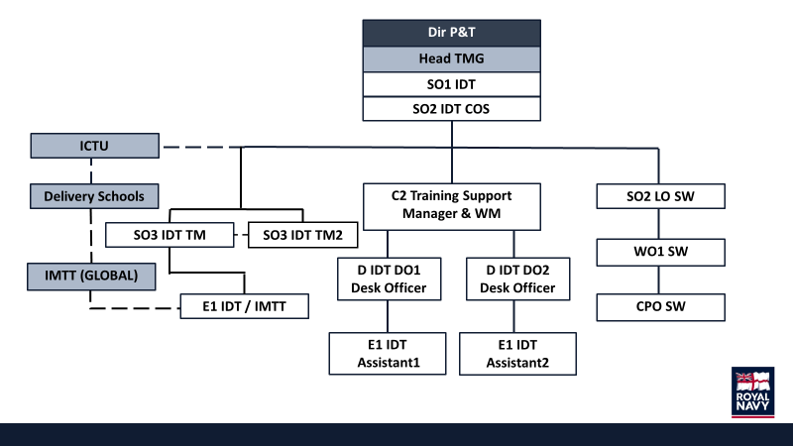

PART C - RESPONSIBILITIES

Responsible for: | Percentage
Management of IDT(RN) training activities both G2G and Wider Markets with strategic partner. Maintain an oversight and understanding of IDT training environment. Including the actioning on In Year Changes to provide training output and the oversight of the implementation of Wider Market contracts such as HTP3. | 40%
Ensure IDT training courses remain current and DSAT compliant, ensuring that courses are developed and modernised in line with feedback and are reviewed on a regular basis. | 15%
Advise the wider IDT team, including IDT SO3 TM2, on Training Management processes, often in line with JSP822 to support decision making. | 15%
Support IDT SO1 in the creation, development and planning of new IDT courses. | 10%
Act as Line Manager to IDT E1, ensuring annual reporting and daily support/CPD is actioned. | 5%
Act on behalf of the IDT TRA to ensure IDT requirements are submitted annually to the SOTR process. | 10%
Advise G2G on appropriate training packages in response to enquiries by foreign nations. | 5%

PART D - AUTHORITY

SO3 IDT is authorised to:

a. Take decisions as appropriate to their primary and secondary purposes.

b. Liaise directly with other Authorities and Commands as appropriate.

c. Liaise directly with members of other Services at the appropriate level.

d. Liaise directly with UK Defence Attachés and Advisors at Embassies and High Commissions overseas and in the UK.

e. Liaise with civilian bodies, contractors and other Authorities as necessary.

- Direct IDT staff in support of IDT purposes.

- Respond to requests and enquiries regarding Government to Government IDT under the direction of SO1/SO2 IDT.

- Deputise for SO2 IDT in their absence as directed.

PART E - SUCCESS PROFILES

The following competencies, experience and behaviours are necessary for the role of IDT(RN) SO3 TM

Competencies:
- In date for all NCT mandatory training.
Knowledge and experience:
- Knowledge of JSP 510 IDT, JSP 822 TM & BR 3 (Naval Personnel Management) (essential).
- Experience and understanding of the Defence System Approach to Training (DSAT) process.
- Experience of training delivery in a RN or professional environment (essential).
- Experience of leading or participating in the senior management of training and education delivery organisations (desirable).
- Experience of developing and maintaining constructive working relationships with partner organisations / commercial partners or working within a commercial environment (desirable).
Behaviours:
- Leadership.
- Communicating and Influencing.
- Working Together.
- Seeing the Big Picture.
- Making Effective Decisions.
- Achieving Commercial Outcomes.
- Delivering at Pace.

PART F - LEARNING & DEVELOPMENT

The post holder will be required to undertake all MOD Mandatory Training related to the post and site.

The post holder will be required to maintain the currency of their knowledge and skills relating to training/ education policies, standards, theories and methodologies through ongoing CPD.

PART F - SIGNATURES

Post holder:
Name | Lt Luke Young RN
Signature

Line Manager:
Name | Lt Cdr Joseph Wood
Signature

Date agreed:
Date for review:

