TERMS OF REFERENCE FOR:

SO3 REGIONAL ENGAGEMENT TEAM LEADER (NRC NE)

Post Title | ROYAL NAVY MEDIA COMMS AND ENGAGEMENT  SO3 REGIONAL ENGAGEMENT TL 2
HRMS, JPA or Magellan Number | 2053520
Rank/Grade | OF2/ OR9
Branch | Military – Royal Navy
Location | NCHQ, LEACH BUILDING, WHALE ISLAND
Level of Security Clearance Required | SC

Background
1. The Director Strategy & Policy organisation leads the development of RN strategy, through a strategic balance of investment process, manages RN engagement with Ministers, the Ministry of Defence, Parliament, the other Front-Line Commands, allied Navies, Other Government Departments, the Maritime Enterprise, academia and think tanks and the general public; developing and coordinating corresponding Navy policy. Dir StratPol is an Executive member of the Navy Board and also oversees its secretariat.

2. The RN HQ Northern England and Isle of Man is one of 4 regional Royal Navy HQs that works to build and maintain relationships with influential individuals and organisations across a range or priority areas, helping to explain the role and relevance of the Royal Navy and the links and benefits that exist across the northern of England and Isle of Man in accordance with the RN Domestic Engagement plan which is own by the RN Domestic Engagement Team (RNDET).

ROLES DESCRIPTION

3. SO3 Regional Engagement Team Leader 2 forms part of a team providing engagement capability to regional stakeholders. The role is parented in HMS EAGLET, Liverpool, as part of RN HQ Northern England and the Isle of Man (RNHQ NE) and provides regional management and delivery of engagement activites, including maritime ceremonial components, as scheduled by the DET though the RNDE central planning function.

4. Georgaphical location. The parent base for the role is HMS EAGLET, Liverpool, and SSSA/SFA can be arranged if required. If the incumbent resides in another county of the northern region they could execute their duties utilising hybrid working, but should note they will be required to spend time on the road and away from the parent unit to deliver regional engagement activities. Travel and subsitency will be provided.

5. Regional Engagement Delivery. Engagement in this context is defined as an act of Communication through the brokering of effective person-to-person contact at an appropriate level. Engagement allows the RN to exert appropriate influence over those groups that have the greatest effect on its future strategic success. Key tasks involve:

- Project management, operational planning and delivery of regional engagement events as scheduled and directed by the central DET planning function.
- Coordinate NRC regional engagement programme.
- Assist in the development of business cases, design of SMS submissions and the management of resulting financial arrangements for regional engagement events, providing information as required to the DET.
- Track, manage and report event expenditure to the DET.
- Provide feedback on the efficacy of regional engagements to CoS NRC NE and the DET, particularly on responses to the Universal Questions and other quantitative and qualitative approaches as deemed appropriate.
6. Military Assistance to Command. This role will be required to offer assistance to Commodore RNHQ NE in support of their official national and regional engagement. Key tasks involve:

- Research and compose briefing material to ensure Commodore RNHQ NE, or their representative, are informed and able to represent the Royal Navy/Armed Forces at key national and regional engagement activities.
- Aid speech writing for engagement activities attended by the Commodore RNHQ NE, or their representative, ensuring key messaging is in support of the wider RNDE plan.
- Conduct weekly planning meetings with RNHQ NE Relations Mangager to ensure future activities and events are planned and prepared for.
- Liaise early with representatives of Commodore RNHQ NE to ensure they are briefed on activities, audiences and key messaging as required.

7. Line Manager (as required). As a Line Manager to ensure staff are managed according to applicable rules and regulations. The key tasks for the Line Manager are:

- Carry out day-to-day staff management, ensuring staff are set clear priorities and are performing within set parameters.
- Review and assess performance of staff based on agreed performance objectives (set annually) and Terms of Reference for the post.
- Be responsible for staff development following Defence development review process and work with Professional Development Lead (if that is a different post holder).
- Handle personnel issues by following Defence personnel procedures.
8. The post holder reports to the RN HQ CoS.

9. The post holder works closely with RN HQ CoS, NLO/DNLO and the other SO3 Enagement TL.

AUTHORITY AND COMMITTEES

10. The post holder is authorised to:

- Liaise with internal and external agencies as required to deliver delegated outputs.
- As directed, liaise with DS Sec (Ceremonial Events and Commemorations Team) as required in the delivery of nationally focused events.
- Liaise and report to RNDET in the delivery, as well as providing feedback of national and regional activities

11. Is a member of:

- Regional Coherency Group (RCG)

12. Attends:

- Full range of DET and NRC Battle Rhythm meetings.

ORGANISATION

13. Organisation Diagram

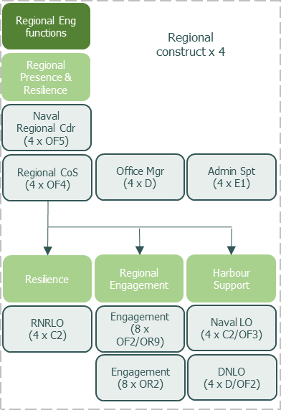

COMPETENCIES AND SKILLS

14. The post holder must have strong leadership and strategic thinking skills, being able to be creative in capitalising on regional engagement opportunities to the benefit of the Royal Navy.

15. Must have excellent people handling skills in both small and large scale events, remaining able to stage manage senior officers and civil servants as required, with the tenacity to handle unexpected circumstances and potentially turn them to the advantage of the Royal Navy.

16. Ideally, the post holder should have acquired some communication skills and knowledge from previous postings. Building on this, the post holder must agree with the Line Manager on the training necessary to attain the required level of GCS communication competency as below:
GCS Communication Competency Framework | Level (0-6)
Insight: Gain an accurate and deep understanding of the issue(s). Use insight to identify target audiences and partners and to inform communication objectives, messages and solutions. | 2
Ideas: Develop the communication strategy and plan. Select channels and develop key messages and content for target audiences. Identify evaluation criteria. | 2
Implementation: Develop and implement effective communication strategies and plans. Work with stakeholders and partners to deliver communication. | 2
Impact: Assess the impact and effectiveness of communication. Review achievement of objectives. Identify lessons learnt and share feedback. | 2

EXPERIENCE

17. Essential experience:

- Defence Engagement and public speaking
- Skills level with Defence ICT (DII/MODNET, MS Office, MOSS)

18. Highly desirable experience:

- ICSC(M)
- DCC/Media Operations
- Line management
- Project Management (PRINCE2, ACMP or equivalent)
- UK/EU Civilian Driving Licence to category C1 and D1

Subject to availability and entitlement iaw JSP 464.

