TERMS OF REFERENCE: PACC SO2 (MIAA TL)

PART A – POST DETAILS

Post Title | TMG PACC MIAA SO2
Grade | OF3
Location | HMS COLLINGWOOD
JPA Number | 2116441
HRMS Job Family/Job Code

Line Manager Name/Grade | TMG PACC SO1
Day-to-day Supervisor (if different)
Countersigning Officer Name/Grade
Working Pattern (FT/PT/Alternative)/hours | FT
Security Clearance Required | SC

PART B - ORGANISATION & BACKGROUND

Details of Organisation/Business Directorate
Under the Selborne contract, the Contractor has responsibility for management of the training output for in scope training locations.
The Authority has a need to establish a suitably resourced and empowered ‘customer’ function to manage the contract, coordinate and manage the provision of Authority enablers and dependencies, and hold the Contractor to account for the delivery of the in-scope training services to the volume and quality standard required by the Authority.
The Authority’s responsibilities as an intelligent customer will be discharged through the Authority component of the Training Management Group (TMG) within the Personnel and Training Directorate. The TMG is the key forum for collaborative working between the Authority and the Contractor at a corporate level, and for the day-to-day management and oversight of the training service.
The Authority’s role as ‘customer’ within the TMG is to oversee, assure, consult, inform and influence, not to determine how the Contractor delivers the contracted services. The Authority component of the TMG constitutes both a centralised team and local ‘key customers’ at the point of training delivery to support the proactive management of the Contractor and the coordination of relevant Authority dependencies.

The TMG operates on a collaborative basis with joint-working between the Authority and Contractor to help each Party achieve their aligned objectives. This includes the Parties working together to identify and resolve risks and issues, and to realise opportunities. It also involves the Parties supporting one another to help fulfil their respective responsibilities and obligations, in accordance with the terms set out in Clause 62 (Cooperation and Collaboration) of the contract. In the case of the Authority, this will mean the provision of technical SME advice and guidance to the Contractor in relation to RN training and education, support in the design and implementation of remedial, opportunity realisation and modernisation plans, and facilitating change elsewhere within the RN which supports and enables the realisation of benefits within the training system.

The Pipeline Accreditation (PACC) teams role is to ensure accreditations requirements for each profession are met within resource envelope. The Military Independent Assessment Authority is the End Point Assessment (EPA) Organisation for a number of Apprenticeship Standards for the RN. The primary role of the MIAA is to act separately from other training aspects to offer unbiased grading assurance on EPAs and to apply for the apprenticeship certification on the Standards it is registered for. The MIAA is externally assured by Ofqual.

Job Purpose

Primary Purpose of the PACC MIAA Team Leader (TL)
- Manage the day to day running of the Military Independent Assessment Authority (MIAA) liaising with all branches to develop EPA solutions.
- Ensure that the MIAA is aligned to Office of Qualifications and Examinations Regulation (Ofqual) standards and act as the Ofqual Responsibility Officer.
- Review and implement MIAA policy, updating it as necessary to continuously improve upon the EPA process.
- Assist the PACC SO1 in the day to day running of the PACC group.
Secondary Purposes
- Manage the MIAA Grading Assessors daily tasking.
- Attend RN and National events on behalf of the PACC group.
- Provide termly feedback to Fleet on EPA outcomes.
- Assist in the development and maintenance of MIAA/EPA funding models.
Organisation Chart
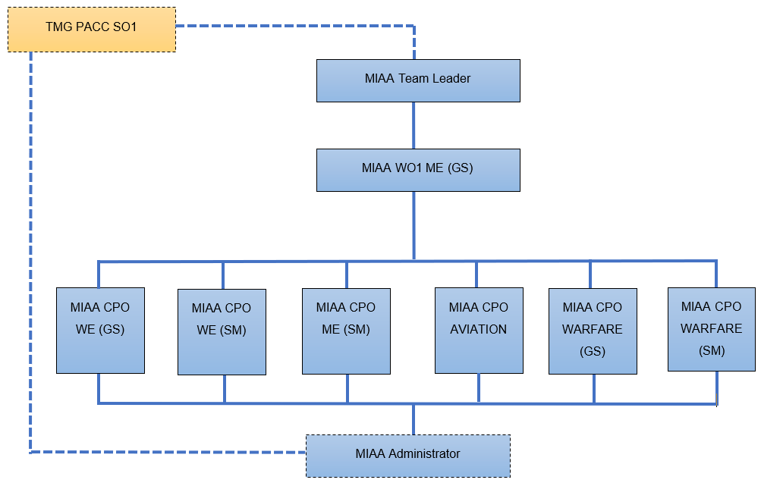
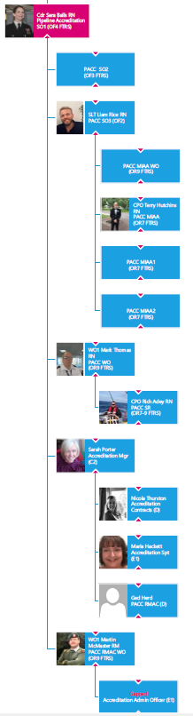

PART C - RESPONSIBILITIES

Responsible for: | Percentage
Manage the day-to-day business of the MIAA | 30%
Liaise/Support Branch Managers with EPA solutions | 20%
Act as the Ofqual Responsibility Officer | 5%
Liaise with TMG PACC SO1 to update Apprenticeship Policies and EPA solutions | 10%
Liaise with Trailblazer Groups in updating existing Apprenticeship Standards | 5%
Identify opportunities to develop MIAA processes to benefit Unit assessors and apprentices, while still meeting government aspirations. | 5%
Implement and maintain relevant MIAA Policies. | 5%
Brief career courses on RN Apprenticeships and EPAs. | 5%
Assist the MIAA WO in the management of the MIAA Grading Assessors and Administrators delivery of EPA documentation to the required Units. | 10%
Collate feedback on EPAs to assist the MIAA Team Leader on monthly fleet updates of good practices and areas of improvement. | 5%

PART D - AUTHORITY

Responsibilities
- The MIAA SO2/Team Leader is accountable to TMG PACC SO1
- 1RO for the Warrant Officer and the 2RO for the Grading Assessors.

PART E - SUCCESS PROFILES

Competencies
- In general, the post holder is OF3
- Essential:
- Must either have been, or currently be an OF3.

- Hold Full Driving License.

- Excellent communication/customer service skills.

- Good IT background/aptitude in MS Office suite of applications.

- Ability to handle multiple tasks/projects simultaneously.

- Working knowledge of Defence Systems Approach to training

- Desirable:

  - Working knowledge of the Royal Navy Apprenticeship Programme.

  - Working knowledge of Apprenticeships and the rules surrounding funding and delivery of Standards based apprenticeships and EPA.

  - Internal Verifier Qualification held – D34/V1/ Level 4 IQA Course

PART F - LEARNING & DEVELOPMENT

The post holder will be required to undertake all MOD Mandatory Training related to the post and site, and to support the training of direct reports.

The post holder will be required to maintain the currency of their knowledge and skills relating to training/ education policies, standards, theories and methodologies through ongoing CPD.

PART F - SIGNATURES

Post holder:
Name

Signature

Line Manager:
Name

Signature

Date agreed:
Date for review:

